Behind Every Workout: Statistical Analysis and Visualization of Gym Member Data

Introduction

This project focuses on analysing gym member exercise data to understand patterns in workout behaviour, calorie expenditure, and performance differences across various demographics. It explores how factors such as age, gender, workout type, and experience level influence fitness outcomes. By applying data cleaning, aggregation, and visualization techniques, the study identifies key trends, correlations, and variations in exercise habits. These insights not only highlight differences in fitness efficiency and workout intensity but also provide a deeper understanding of how individuals engage with their routines, helping to inform more effective and personalized fitness strategies.

The objective of this analysis is to:
- Identify trends in calorie burn and workout duration
- Compare performance across age groups and gender
- Explore relationships between workout variables
- Derive meaningful insights using data visualization
The project follows a complete data analysis workflow including preprocessing, Exploratory Data Analysis (EDA), and Visualization.

Dataset Description

- Source: https://www.kaggle.com/datasets/valakhorasani/gym-members-exercise-dataset - Kaggle (Gym Members Exercise Dataset)
- Number of Records/Rows: 973
- Number of Attributes/Columns: 15

Key variables used:
- age – Age of the individual
- gender – Male/Female
- session_duration_(hours) – Workout duration
- calories_burned – Total calories burned per session
- age_group – Categorized age (created column)

Data Preprocessing

The dataset was cleaned and prepared before analysis using the following steps:

3.1 Handling missing values:
- Checked for null values using df.isnull().sum()
- No significant missing values were found

3.2 String manipulation and data cleaning:
- Spaces were replaced with underscores using:
- df.columns = df.columns.str.strip().str.lower().str.replace(" ", "_")
- Text in the ‘gender’ attribute was converted to lowercase for easier handling using:
- df['gender'] = df['gender'].str.lower()
- Renamed columns where necessary for clarity

3.3 Data Transformation:

- Created a new bmi_category attribute to distribute members of different BMI index into categories like:
- Underweight
- Normal
- Overweight
- Obese

- Created a new age_group attribute by grouping(binning) ages into categories such as:
  - Young (18–25)
  - Adult (26–40)
  - Middle-aged (41–60)

- Created a new fitness efficiency metric calories_per_hour attribute using:
df['calories_per_hour'] = df['calories_burned'] / df['session_duration_(hours)']

Aggregation & Grouping:

- Used groupby() to analyse:
  - Calories burned by gender
  - Session duration by age group
  - Combined analysis of age group and gender

Visualisation and Analysis

4.1 Load the Gym Members Exercise dataset and display its basic structure:
- Preview the first 10 records.
- Number of rows and columns.
- Inspect the dataset for missing values and handle them appropriately.

4.2 Classify individuals based on their BMI indices in a new attribute ‘bmi_category’.

4.3 Create a new feature ‘age_group’ by categorizing age into meaningful groups.

4.4 Compute summary statistics:
- average calories burned by each workout type.
- average BMI by gender.
- average workout frequency for each experience level.

4.5 Interpret which workout types are the most and least effective in terms of calorie burn using an appropriate visualisation. (Figure 1)
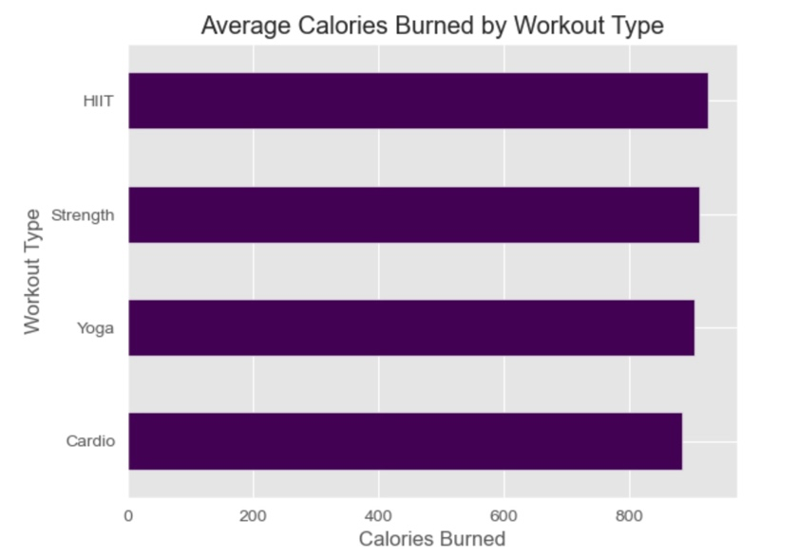
- The most effective workout type in
terms of calorie burn is HIIT with an
average of 925.81 calories burned, while
the least effective is Cardio with 884.51
calories burned.

4.6 Analyse the distribution of BMI among gym members using a histogram and identify patterns in the data.
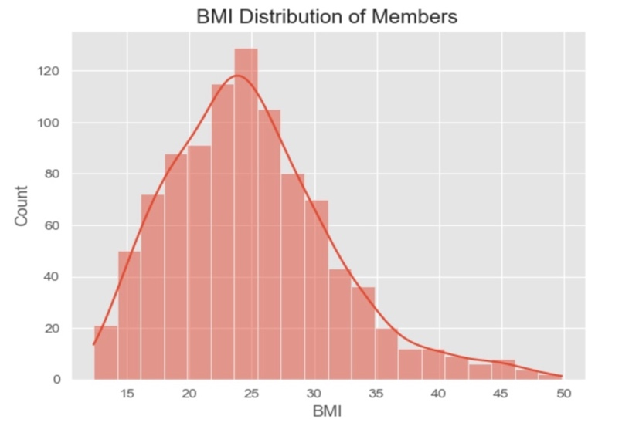
- The BMI distribution of gym
members is centred around a mean of 24.91 and a median of 24.16.

4.7 Compare calorie expenditure across genders and display the distribution using a box plot.
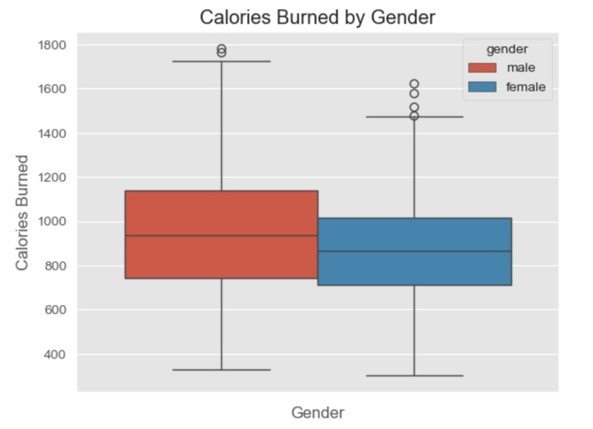
- Males tend to burn slightly more
calories on average, with a wider
distribution indicating greater
variability in workout intensity.

4.8 Examine how workout frequency differs across age groups using a bar plot.
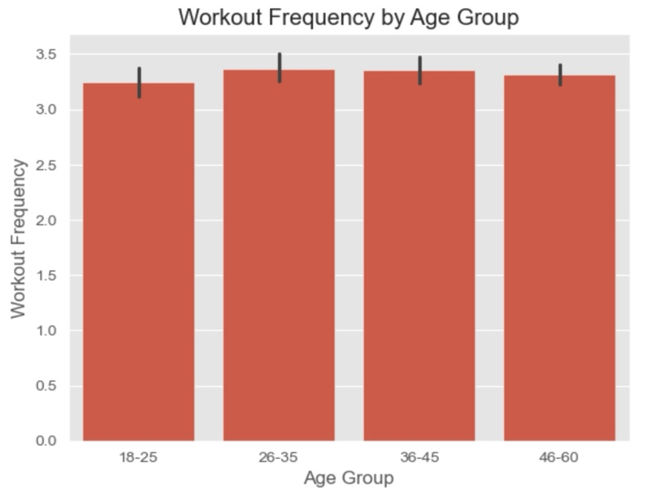
- Workout frequency is fairly
consistent across all age groups, with only slight variations between 3 and
3.5 days per week.

4.9 Determine how workout duration changes with increasing experience level and represent the trend using an appropriate visualization.
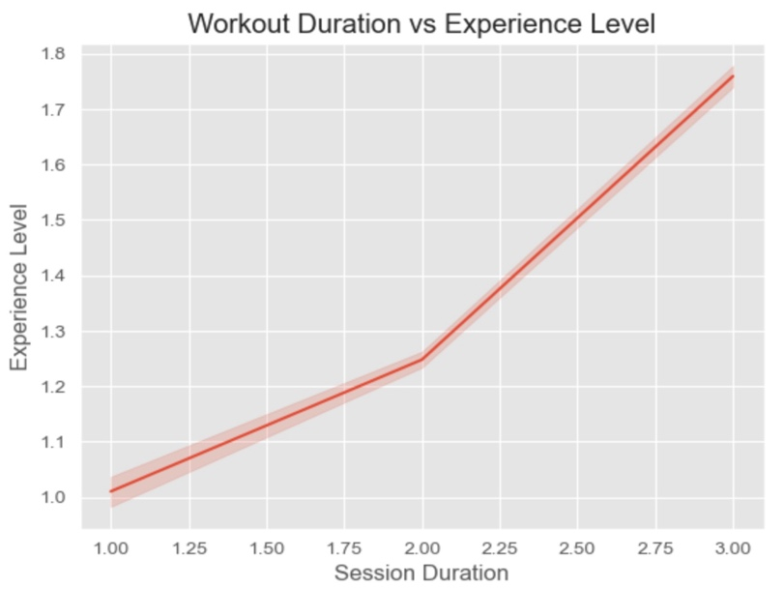
- Workout duration generally
increases with experience level,
though the trend is not perfectly
consistent across all levels.

4.10 Illustrate the distribution of individuals across different BMI categories using an appropriate visualization.
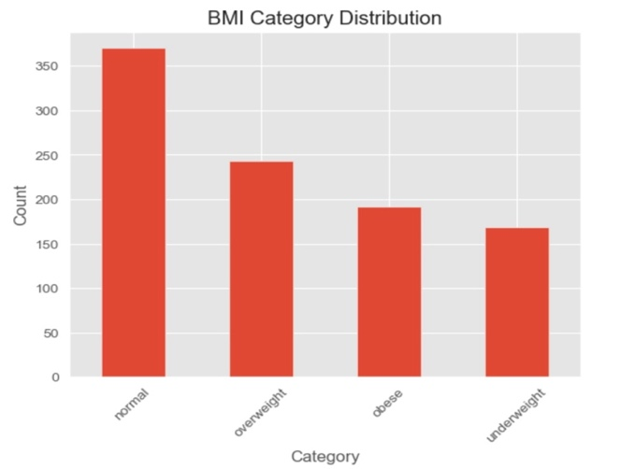
- Most individuals fall under
the normal BMI category, followed by overweight and obese groups,
while the underweight category has the lowest count.

4.11 Explore the relationship between workout duration and calories burned, highlighting differences across genders using a scatter plot.
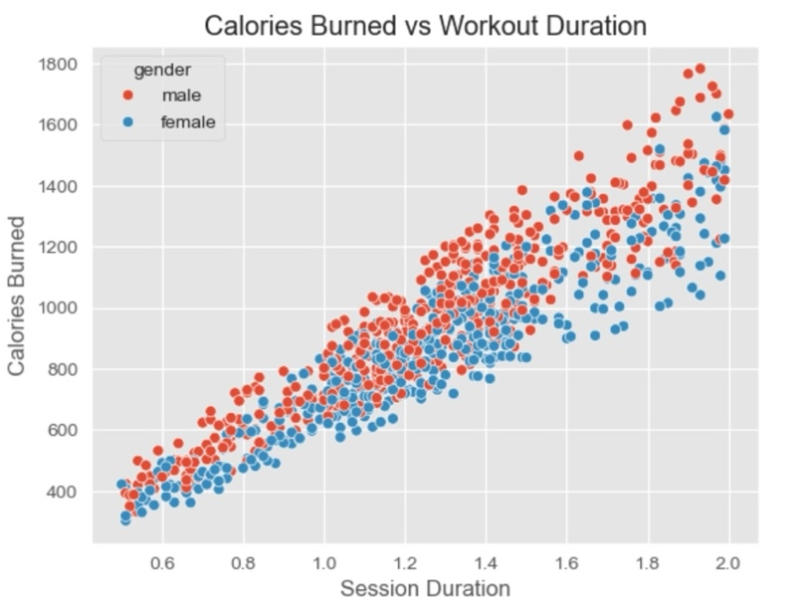
- There is a positive relationship
between workout duration and
calories burned, with males
reaching up to 1783.00 calories
and females going as low as
303.00 calories.

4.12 Examine how calorie burn varies across age groups with a comparison between genders using a bar plot.
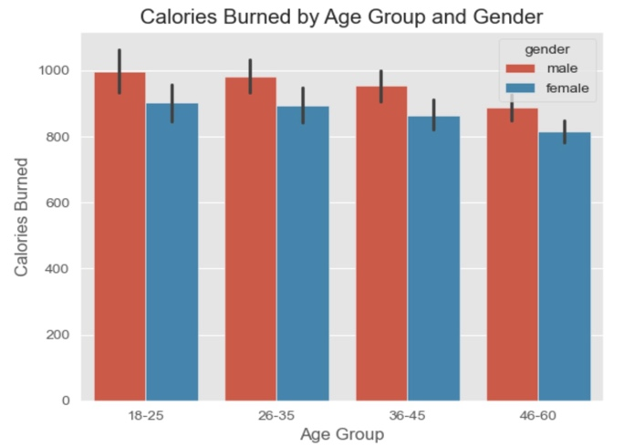
- Calorie burn varies slightly
across age groups, with
consistent gender differences
observed within each group.

4.13 Investigate how different workout types are distributed across various experience levels using a count plot.
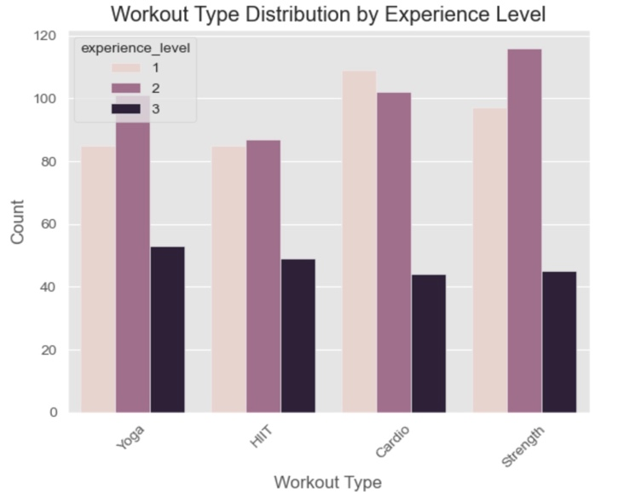
- Workout types are fairly evenly
distributed across experience levels,
with some variations indicating
preferences for certain workouts at
different levels.

4.14 Assess how workout frequency varies across different BMI categories using a box plot.
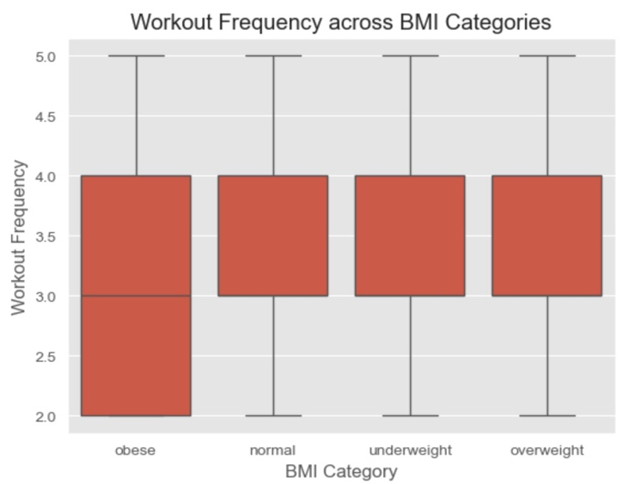
- Workout frequency is slightly
lower and more variable in the obese category (2–4 days/week), while
other BMI groups show a more
consistent range of 3–4 days/week.

4.15 Evaluate how fitness efficiency (calories burned per hour) differs across experience levels using a box plot.
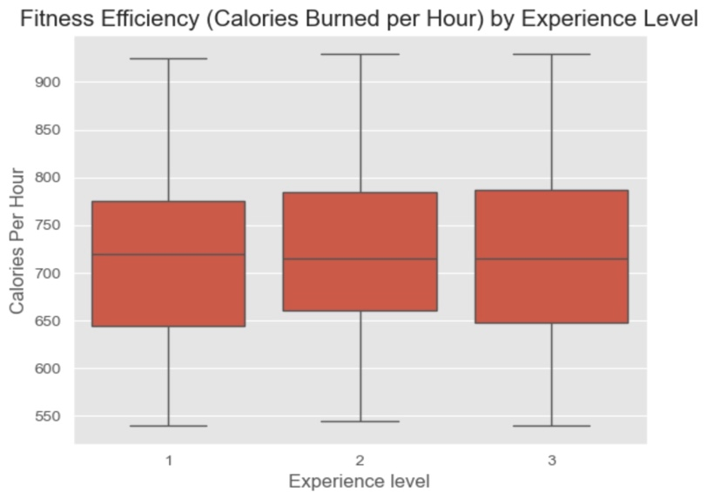
- Fitness efficiency tends to
improve with higher experience
levels, showing higher median
calories burned per hour and
slightly reduced variability.

Key Insights

- There is a positive correlation between workout duration and calories burned.
- Certain age groups tend to exercise longer, impacting calorie expenditure.
- Gender-based differences exist in workout performance.
- Most users fall within a moderate fitness activity range.
- A few outliers indicate high-performance individuals with intense workouts.

Tools Used
- Python
- Pandas
- Matplotlib
- Seaborn
- Jupyter Notebook

Conclusion

This project successfully analysed gym member data to uncover patterns in workout behaviour and performance.
The visualizations revealed clear relationships between workout duration, calorie burn, age, gender, and experience level, highlighting how different factors influence fitness outcomes.
Additionally, the analysis identified variations in workout preferences, consistency across age groups, and differences in fitness efficiency among individuals. The inclusion of derived features such as BMI categories and calories burned per hour further enhanced the depth of the analysis.
These insights can be valuable for designing personalized fitness plans, improving workout efficiency, and understanding overall fitness trends within a population.
Overall, the project demonstrates how data preprocessing, exploratory analysis, and visualization techniques can transform raw data into meaningful and actionable insights, supporting better decision-making in health and fitness contexts.

